PNC Algorithm

[17. The IF bloc](https://pnc-blocky.netlify.app/exercices/2019/e-4-1/index.html)

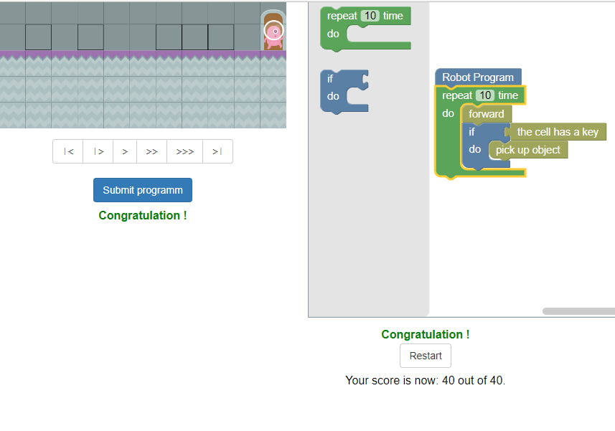

[18. The keys on 2 stairs](https://pnc-blocky.netlify.app/exercices/2019/e-4-2/index.html)

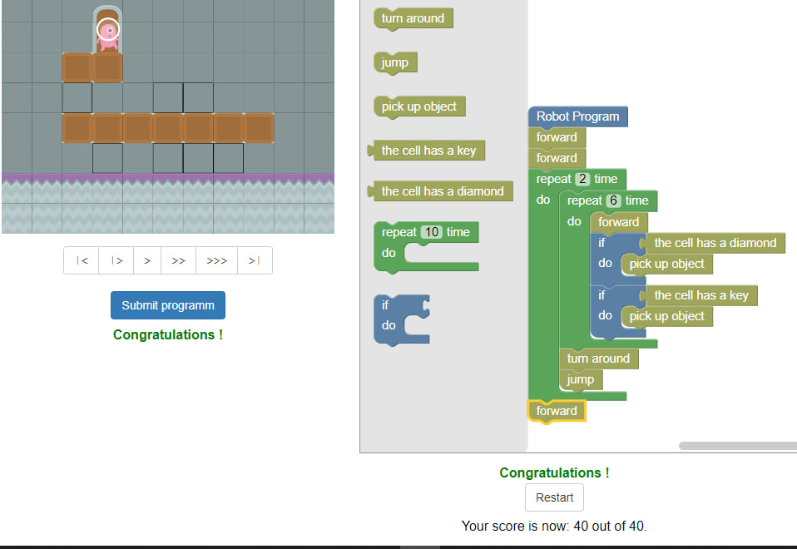

[19. The square of diamonds V2](https://pnc-blocky.netlify.app/exercices/2019/e-4-3/index.html)

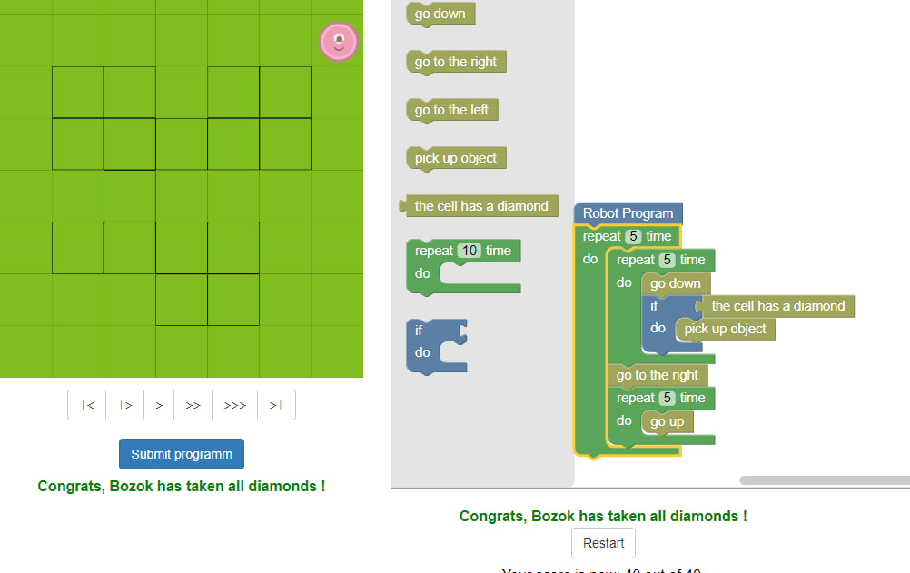

[20. The 4 stairs of diamonds](https://pnc-blocky.netlify.app/exercices/2019/e-4-4/index.html)

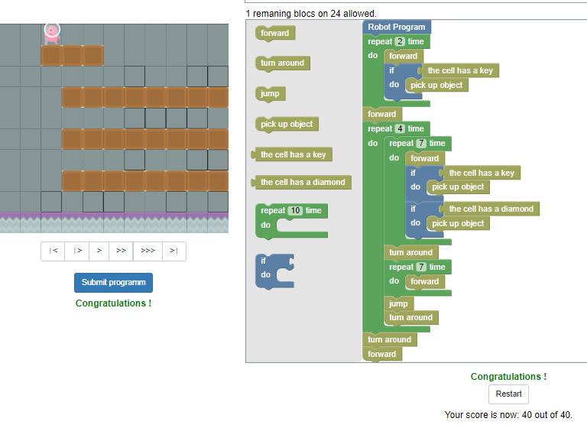

[21. The lockers anywhere !](https://pnc-blocky.netlify.app/exercices/2019/e-4-5/index.html)

